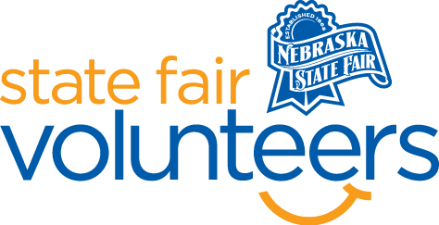

**NSF Volunteer Information Sheet**

***Thank you for offering your time and efforts for the Nebraska State Fair! Your time is very valuable to us, and we appreciate everything that you have to offer to make the Nebraska State Fair a success.***

**Volunteer Position: Visual Arts**

• **Check-In:**

* Your yellow name badge will be your gate admission into the fair. It is to only be used on days that you are volunteering.
* All volunteers are required to check-in with the volunteer coordinator at Volunteer Headquarters (VHQ) in the Pinnacle Expo Building prior to their shift.
* VHQ assistants will check you in and share the location of where your shift begins.

• **Location: 4-H/FFA Fieldhouse**

• **Responsibilities:**

* **Pre-Fair**
  + August 13 & 14 need 4 volunteers 8am-noon, 12pm-4pm, 4pm-8pm to help with accepting, tagging, and displaying exhibits.
  + August 16th need 3 volunteers 9am-12pm and 12pm-4pm to scribe for judges.
* **During Fair**
  + Watch to be sure displays/exhibits are not damaged or taken.
  + Answer questions guests may have. Ex.) Where is the nearest restroom, where are the other open class exhibits displayed?
  + Volunteers need to know:
    - Visual Arts exhibits do not have to qualify at the county level to enter the Nebraska State Fair.
    - Ribbon Placings are as follows: 1st Place – Blue, 2nd Place – Red, 3rd Place – White, 4th Place – Pink, 5th Place – Yellow. They are not the same as 4-H.
* **Exhibit Release**
  + Monday, September 1st need 8 volunteers from 6pm-8:30pm to supervise exhibit release.
  + Tuesday, September 2nd need 2 volunteers from 8am-noon to supervise exhibit release.

• **Requirements:**

* Indoors
* Lifting Requirements: No more than 10 pounds.
* Pre-Fair
  + Standing majority of the time putting exhibits on tables or in display cases.
* During Fair
  + Roving the area majority of the time interacting with fair guests.
* Exhibit Release
  + Standing majoriy of the time.

• **Check-Out:**

* Volunteers do not need to check out at VHQ as the new system will automatically check you out.