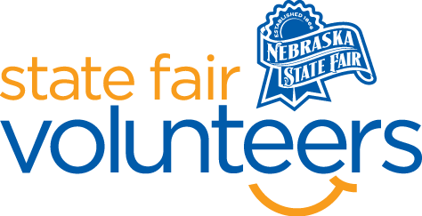
NSF Volunteer Information Sheet
Thank you for offering your time and efforts for the Nebraska State Fair! Your time is very valuable to us, and we appreciate everything that you have to offer to make the Nebraska State Fair a success.

Volunteer Position: Tea Party Volunteer
Date/s: Sunday, August 24th
Shift/Time Needed: 10:00 am – 1:00 pm (event 11 am – 12:30 pm)
Number of Volunteer/s Needed: 3

• Check-In:
- Your yellow name badge will be your gate admission into the fair. It is to only be used on days that you are volunteering.
- All volunteers are required to check-in with the volunteer coordinator at Volunteer Headquarters (VHQ) in the Pinnacle Expo Building prior to their shift.
- VHQ assistants will check you in and answer any questions you have before your shift begins.
- Please check in 15 minutes prior to the start of your shift.

• Location:
- Hospitality Loft (second floor of Five Points Bank Arena).

• Responsibilities:
- Using the provided check-in materials, check in Nebraska titleholders as they arrive to volunteer at the event. Titleholder check-in will be from 10:15 am to 10:45 am.
- Assist with guests arriving. Each child must have a tea party ticket to gain entry.
- Nebraska titleholders will be helping at different stations (greeting, crafts, refreshments, photobooth, etc.). Be present to assist them with their roles as needed.
- Tidy the space as guests leave. Return check-in materials to VHQ after your shift.

• Requirements:
- Indoors or Outdoors: Indoors, some standing.
- Lifting Requirements: No lifting is required.

• Check-Out:
- Volunteers do not need to check out at VHQ as the new system will automatically check you out.

