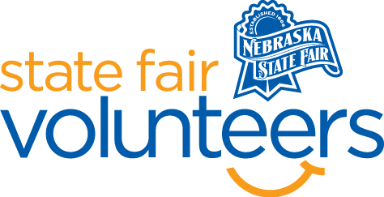

**NSF Volunteer Information Sheet**

***Thank you for offering your time and efforts for the Nebraska State Fair! Your time is very valuable to us, and we appreciate everything that you have to offer to make the Nebraska State Fair a success.***

**Volunteer Position: Raising Nebraska - Map**

**Date/s: All Days**

**Excluding August 23 from 10am-2pm**

**Excluding August 25 from 2pm-6pm Shift/Time Needed: 10am-2pm & 2pm-6pm**

**Number of Volunteer/s Needed: 1**

• **Check-In:**

* Your yellow name badge will be your gate admission into the fair. It is to only be used on days that you are volunteering.
* All volunteers are required to check-in with the volunteer coordinator at Volunteer Headquarters (VHQ) in the Pinnacle Expo Building prior to their shift.
* VHQ assistants will check you in and answer any questions you have before your shift begins.
* Please check in 15 minutes prior to the start of your shift.

• **Location:**

* + Nebraska Building in the Raising Nebraska space, by the Walkable Map.

• **Responsibilities:**

* Assist fairgoers with the purpose of the map and the Platte River Time Lapse footage to ensure the fairgoer is getting the most out of their experience. Many of the guests who interact with the map are younger visitors who may not understand that they should not climb on railings surrounding the map and/or that the map has a slick surface and that they could slip. Please help remind the youth and their families about safety on and around the map area.
* Be familiar with the Raising Nebraska Exhibit and the all the areas available for guests to see. We will have materials available to help you.
* GREET GUESTS IN A HAPPY AND POSITVE MANNER. Welcome and interact with the fairgoers who enter Raising Nebraska Map exhibit.
* BE READY TO GET THE SAME QUESTION OFTEN. Be available for other questions about the Fair and to have other related discussions the person may be interested in having with you.
* HAVE FUN!
* Inform Raising Nebraska staff if you get questions you cannot answer or if there is an exhibit that is not working correctly.

• **Requirements:**

* Indoors or Outdoors: Indoors air-conditioned building
* Lifting Requirements: Possible light lifting moving chairs and tables around as needed.

• **Check-Out:**

* Volunteers do not need to check out at VHQ as the new system will automatically check you out.
* Raising Nebraska will provide you with a clipboard to use during your shift with a schedule of the activities happening at Raising Nebraska that day. This clipboard should be passed on to the next volunteer at the end of your shift or returned to Raising Nebraska staff.