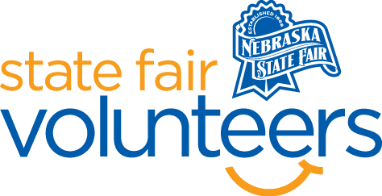

**NSF Volunteer Information Sheet**

***Thank you for offering your time and efforts for the Nebraska State Fair! Your time is very valuable to us, and we appreciate everything that you have to offer to make the Nebraska State Fair a success.***

**Volunteer Position: Raising Nebraska – Fashion Show Usher**

**Date/s: August 23 Shift/Time Needed: 8:30am-2pm**

**Number of Volunteer/s Needed: 2-4**

• **Check-In:**

* Your yellow name badge will be your gate admission into the fair. It is to only be used on days that you are volunteering.
* All volunteers are required to check-in with the volunteer coordinator at Volunteer Headquarters (VHQ) in the Pinnacle Expo Building prior to their shift.
* VHQ assistants will check you in and answer any questions you have before your shift begins.
* Please check in 15 minutes prior to the start of your shift.

• **Location:**

* + Will be positioned in the Nebraska Building in the Raising Nebraska space.
    - Please report to the South Doors by the Foyer.

• **Responsibilities:**

* The fashion show is always a packed house and your job would be to help direct people to empty seats, move chairs for wheelchairs, help direct people who are standing to find better vantage points.
* Like everywhere at the Fair, something gets left. After each of the Fashion Shows, you would help pick up trash or items left by the audience, reset chairs, help with cleaning up spills, etc.
* Welcome and interact the fairgoers who enter Raising Nebraska for the 4-H Fashion Show in a happy and positive manner
* BE READY TO GET THE SAME QUESTION OFTEN. Be available for other questions about the Fair and to have other related discussions the person may be interested in having with you.
* HAVE FUN!
* Inform Raising Nebraska staff if you get questions you cannot answer.

• **Requirements:**

* Indoors or Outdoors: Indoors air-conditioned building
* Lifting Requirements: Possible light lifting moving chairs and tables around as needed.

• **Check-Out:**

* Volunteers do not need to check out at VHQ as the new system will automatically check you out.
* Lunch Breaks will be provided, but it might not be right at noon, due to timing of the shows*.*