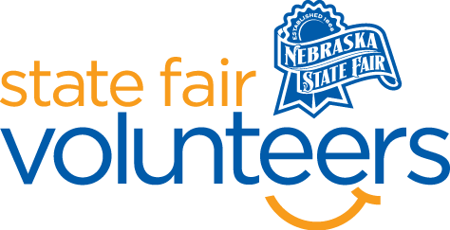
NSF Volunteer Information Sheet
Thank you for offering your time and efforts for the Nebraska State Fair! Your time is very valuable to us, and we appreciate everything that you have to offer to make the Nebraska State Fair a success.

Volunteer Position: Puzzle Contest Volunteer
Date/s: Saturday, August 30th
Shift/Time Needed: 3:00 pm – 6:30 pm (event 4-6 pm)
Number of Volunteer/s Needed: 3

• Check-In:
- Your yellow name badge will be your gate admission into the fair. It is to only be used on days that you are volunteering.
- All volunteers are required to check-in with the volunteer coordinator at Volunteer Headquarters (VHQ) in the Pinnacle Expo Building prior to their shift.
- VHQ assistants will check you in and answer any questions you have before your shift begins.
- Please check in 15 minutes prior to the start of your shift.

• Location:
- Fonner Park Concourse (1st floor)

• Responsibilities:
- Using the provided check-in materials, check in teams and give them their puzzle and table assignments.
- During the contest, walk around tables to ensure teams are following rules and be available if they have any questions.
- You will have a stopwatch, and there will be team slips at every table. As teams finish their puzzle, record their time on their slip. Prizes are awarded to the first three teams, but all teams will have two hours to complete their puzzle.
- Assist with prizes after the contest.

• Requirements:
- Indoors or Outdoors: Indoors, standing.
- Lifting Requirements: No lifting is required.

• Check-Out:
- Volunteers do not need to check out at VHQ as the new system will automatically check you out.

