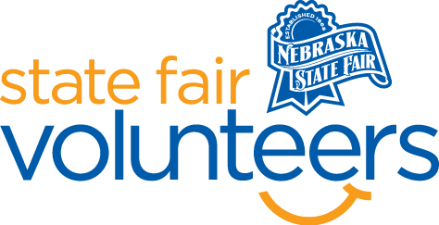

**NSF Volunteer Information Sheet**

***Thank you for offering your time and efforts for the Nebraska State Fair! Your time is very valuable to us, and we appreciate everything that you have to offer to make the Nebraska State Fair a success.***

**Volunteer Position: Photography Department**

• **Check-In:**

* Your yellow name badge will be your gate admission into the fair. It is to only be used on days that you are volunteering.
* All volunteers are required to check-in with the volunteer coordinator at Volunteer Headquarters (VHQ) in the Pinnacle Expo Building prior to their shift.
* VHQ assistants will check you in and share the location of where your shift begins.

• **Location: 4-H/FFA Fieldhouse**

• **Responsibilities:**

* **Pre-Fair**
  + August 17th 9am-2pm need 2 volunteers to help with judging.
  + August 18th 9am-noon need 2 volunteers and 12pm-3pm need 2 volunteers to help hang photos in the hallway.
  + August 19th 9am-noon need 2 volunteers to help hang photos in the hallway.
* **During Fair**
  + Be familiar with locations of various classes to assist exhibitors and guests in locating specific photographs.
  + Monitor and remind guests not to touch the photographs.
  + Use exhibitor book to help find photographs.
  + Encourage people to vote for people’s choice.
  + Replace photographs on walls that come down.
  + One volunteer will be stationed at the photography information table.
  + Do your homework. Be familiar with the Nebraska State Fair gate book: daily schedules, general fair information, and the grounds map.
  + Be prepared to get asked the same questions often. Deliver your answer as if it is the first time you have heard that question with a helpful smile.
  + Be ready to use a grounds map and landmarks to direct guests to their destination.
  + Remain calm, positive, and helpful at all times. Unfortunately, a few guests may see you as an outlet for complaints. Help the guest whenever you can and direct them to a more appropriate outlet when you cannot be of assistance. Nebraska State Fair Administration Office is often the necessary destination so know how to direct complaints there.
  + Greet guests in a happy and positive manner and don’t forget to smile.
* **Exhibit Release**
  + September 1st 5pm-8pm need 4 Volunteers to help assist taking photos off the wall and help finding photos for exhibitors.
  + September 2nd 8am-noon need 2 Volunteers to assist with finding photos for exhibitors,

• **Requirements:**

* Indoors
* Lifting Requirements: none
* Sitting: Position at the table - over 90% of the time but will need to get up and check the photographs in the hall intermittently to make sure none have fallen.

• **Check-Out:**

* Volunteers do not need to check out at VHQ as the new system will automatically check you out.