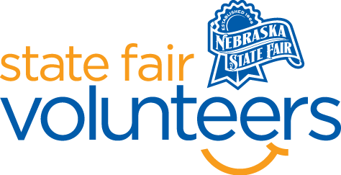
NSF Volunteer Information Sheet
Thank you for offering your time and efforts for the Nebraska State Fair! Your time is very valuable to us, and we appreciate everything that you have to offer to make the Nebraska State Fair a success.

Volunteer Position: Low Sensory Room Volunteer
Date/s: Friday, August 22nd – Monday, September 1st
Shift/Time Needed: 9 am – 8 pm (9 am – 1 pm, 1 pm – 5 pm, 5 pm – 8 pm)
Number of Volunteer/s Needed: 1 per shift per day

• Check-In:
- Your yellow name badge will be your gate admission into the fair. It is to only be used on days that you are volunteering.
- All volunteers are required to check-in with the volunteer coordinator at Volunteer Headquarters (VHQ) in the Pinnacle Expo Building prior to their shift.
- VHQ assistants will check you in and answer any questions you have before your shift begins.
- Please check in 15 minutes prior to the start of your shift.

• Location:
- The low sensory room is room 5 of the Bosselman Conference Center (southeastern corner of the Heartland Events Center). You will have a seat next to the entrance of the room.

• Responsibilities:
- Sit outside the low sensory room and monitor those entering/leaving the room. Feel free to make a note of how many guests visit the room during your shift.
- Tidy the space after the guests leave.
- Ensure that the space is being used for its given purpose: allowing individuals to re-regulate in a high sensory environment. If you feel that individuals in the room are not using the space for this, please ask them politely to redirect or leave the space.
- If you have any questions or concerns during your shift, please feel free to contact Olivia Koenig at (612) 756-5483.
• Requirements:
- Indoors or Outdoors: Indoors; a chair will be provided.
- Lifting Requirements: Minimal lifting and tidying of the space will be required.
• Check-Out:
- Volunteers do not need to check out at VHQ as the new system will automatically check you out.

