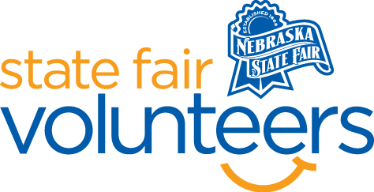

**NSF Volunteer Information Sheet**

***Thank you for offering your time and efforts for the Nebraska State Fair! Your time is very valuable to us, and we appreciate everything that you have to offer to make the Nebraska State Fair a success.***

**Volunteer Position: Raising Nebraska – Evening Volunteers**

**Date/s: All Days Shift/Time Needed: 6pm-9pm**

**Number of Volunteer/s Needed: 2**

• **Check-In:**

* Your yellow name badge will be your gate admission into the fair. It is to only be used on days that you are volunteering.
* All volunteers are required to check-in with the volunteer coordinator at Volunteer Headquarters (VHQ) in the Pinnacle Expo Building prior to their shift.
* VHQ assistants will check you in and answer any questions you have before your shift begins.
* Please check in 15 minutes prior to the start of your shift.

• **Location:**

* + Will be positioned in the Nebraska Building in the Raising Nebraska space.

• **Responsibilities:**

* Our programming day is over by 6 pm, but this shift is when we need help cleaning up from earlier in the day and getting things ready for next day's activities. This may include setting-up and taking down tables and chairs, wiping down tables and chairs, cleaning touchscreens and exhibits, taking out trash, sweeping the floor, and cleaning up spills. Maybe even helping repair broken exhibits!
* Be familiar with Raising Nebraska and the all the areas available for guests to see and interact with. We will have materials to help you and you'll probably have time to play and explore.
* Welcome and interact the fairgoers in a happy and positive manner.
* ASSIST GUESTS. Assist fairgoer's with general fair questions and about activities within the Raising Nebraska space. This may involve assisting guests with opening exterior doors.
* BE READY TO GET THE SAME QUESTION OFTEN. Be available for other questions about the Fair and to have other related discussions the person may be interested in having with you.
* HAVE FUN!
* Inform Raising Nebraska staff if you get questions you cannot answer or if there is an exhibit that is not working correctly.

• **Requirements:**

* Indoors or Outdoors: Indoors air-conditioned building
* Lifting Requirements: Possibly light lifting moving chairs and tables around

• **Check-Out:**

* Volunteers do not need to check out at VHQ as the new system will automatically check you out.