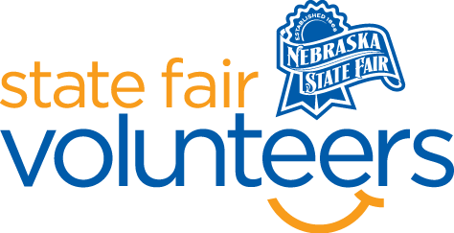
NSF Volunteer Information Sheet
Thank you for offering your time and efforts for the Nebraska State Fair! Your time is very valuable to us, and we appreciate everything that you have to offer to make the Nebraska State Fair a success.

Volunteer Position: Cheer & Dance Exhibition Volunteer
Date/s: Saturday, August 23rd
Shift/Time Needed: 10:30 am – 1 pm
Number of Volunteer/s Needed: 2

• Check-In:
- Your yellow name badge will be your gate admission into the fair. It is to only be used on days that you are volunteering.
- All volunteers are required to check-in with the volunteer coordinator at Volunteer Headquarters (VHQ) in the Pinnacle Expo Building prior to their shift.
- VHQ assistants will check you in and answer any questions you have before your shift begins.
- Please check in 15 minutes prior to the start of your shift.

• Location:
- AGI Stage

• Responsibilities:
- You will receive a stage performance schedule with the check-in resources.
- Make a note on the check-in sheet when groups arrive for their performance. If a team does not show up, make a note of this as well.
- Be available if coaches have any questions. You may sit and watch each performance.
- After a team has performed, remind coaches that teams must be at the parade staging area 30 minutes prior to the parade IF they are participating (by 1:30 pm). They will receive their stipend checks after completing the parade.
- Return all the Cheer & Dance materials to VHQ after all teams are done for the day.
- If you have any questions or concerns during your shift, please feel free to contact Olivia Koenig at (612) 756-5483.
• Requirements:
- Indoors or Outdoors: Outdoors; you may sit in the audience bleachers.
- Lifting Requirements: No lifting is required.
• Check-Out:
- Volunteers do not need to check out at VHQ as the new system will automatically check you out.

